HOW TO ANALYZE CORPUS CALLOSUM (CC) LENGTH AND AREA MEASUREMENTS

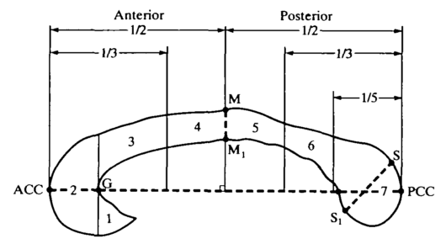
Primarily, one has to notice that there are two main division of the CC: Witelson (1989) and Hofer (2002), explained as follows:
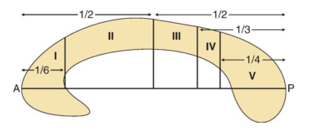
WITELSON
Diagram of the midsagittal view of the corpus callosum of the human adult, showing the seven regional subdivisions used for area measurement, numbered 1-7 (rostrum, genu, rostral midbody, anterior midbody, posterior midbody, isthmus, splenium). G, the anteriormost point on the inner convexity of the anterior callosum
HOFER
Region I: prefrontal; region II: premotor and supplementary motor; region III: motor; region IV: sensory; region V: parietal, temporal, and occipital. A, anterior; P, posterior.

Secondly, the MRI or US images must be previously download from RaiAlma, saved as DICOM in properly labelled folders as (patientnumber+slice orientation, eg.: 00001sagital). These images must be stored inside the folder CC_images here in the computer who was installed the matlab package at the Brain Connectomics Office. Remember that you must be blind to the group of cases and control, otherwise you will be adding one bias in the analysis.

- LOGIN IN THE COMPUTER.
Login user: connectomics
Password: networks2015
- LAUNCH MATLAB (Click on the desktop icon):


- PARAMETER SETTING IN MATLAB

  - In Matlab Command window, write cd(´/home/connectomics/Desktop/GUI_CC') to change the directory where the CC tools are.
*If you click on arrow up, you can already find the complete address, with no need to type it all.
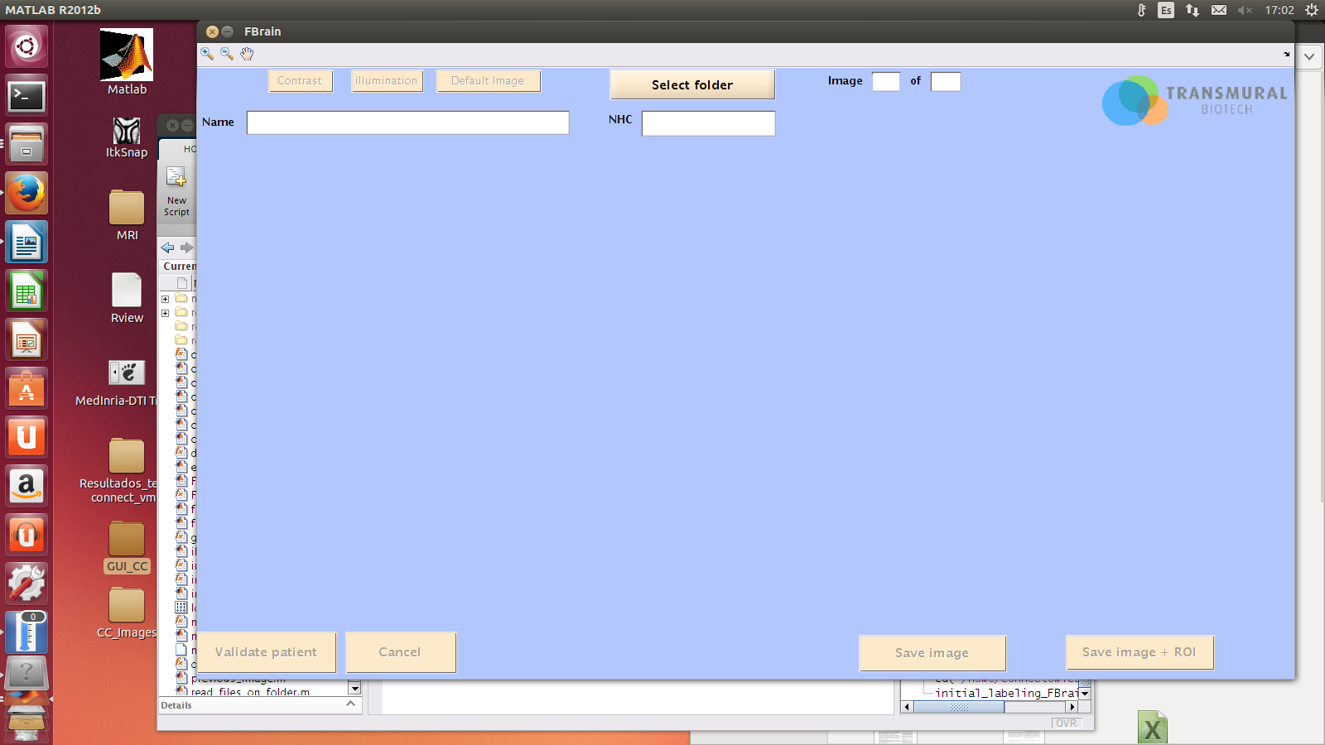
  - Open the script for GUI_CC. In Matlab Command window, write initial_labeling_FBrain and click enter. This command opens the matlab package application we will work on.

The interface is the following:

3.3. Path to images. Go on 'Select folder' and find the images you want to analyze inside the folder CC_images. Remember that for this analyzes you must have sagital slices. Click OK.
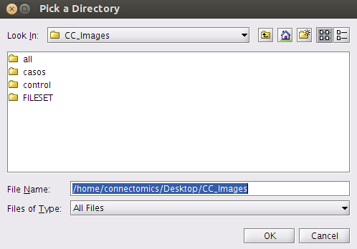

3.4. By clicking OK, the program will confirm the conversion and opening of the DICOM images to be properly read. You will see the following window:
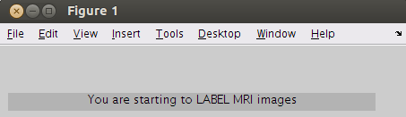
3.5. By clicking enter you will see the first image on the program window:
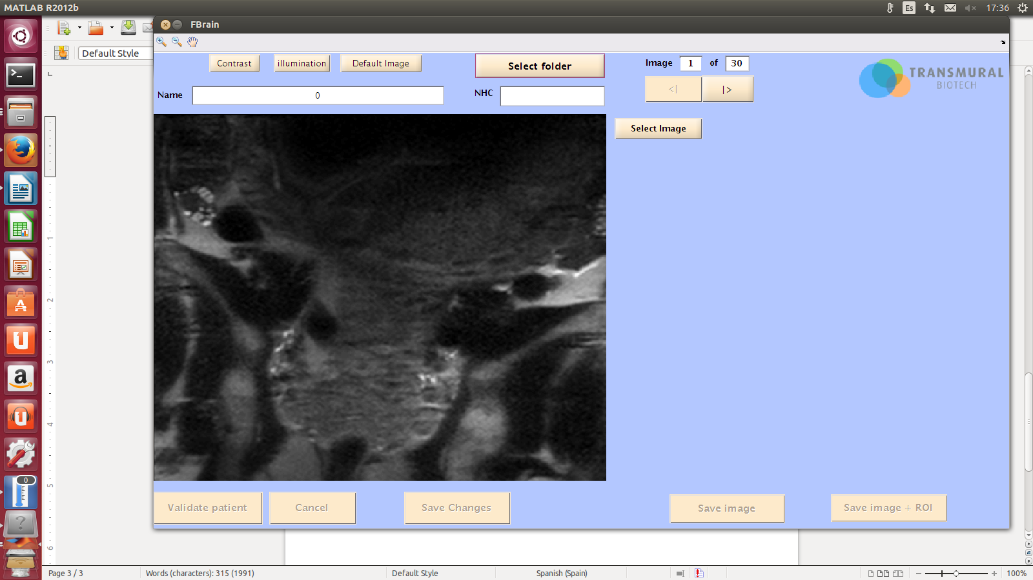

3.6. On the upper right part, there are arrows to change the image slice and upper left there are the zoom in, zoom out, contrast and illumination tools. Try and find the better slice that reveals the corpus callosum in the midsagital plase as a slightly curved horizontal T2-weighted hypointense structure. Remember that the anatomical landmarks are: cavum septi pellucidi, thalamus, midbrain, cerebellar vermis and cisterna magna.
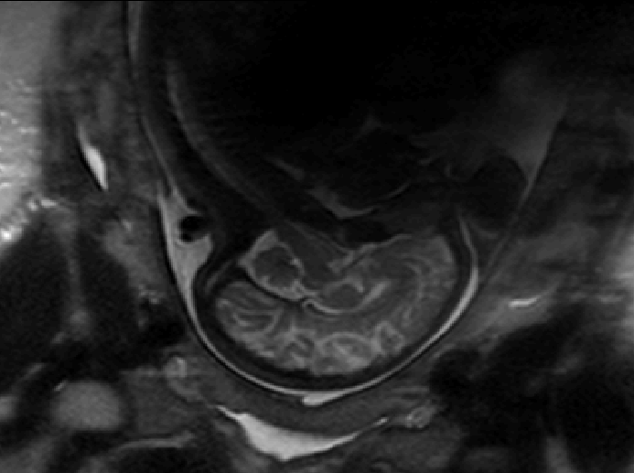

3.7. Play with the zoom and brightness to get a better delimitation of the entire CC.
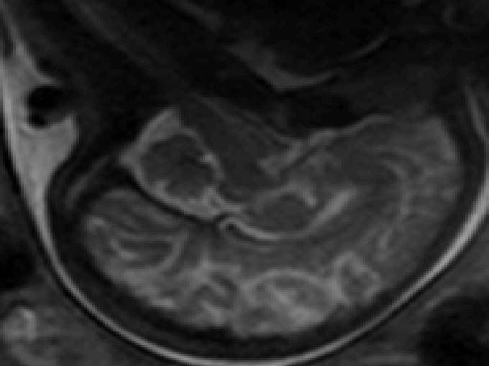
Click on 'Select Image' and the parameters will appear for you to start your delineation.
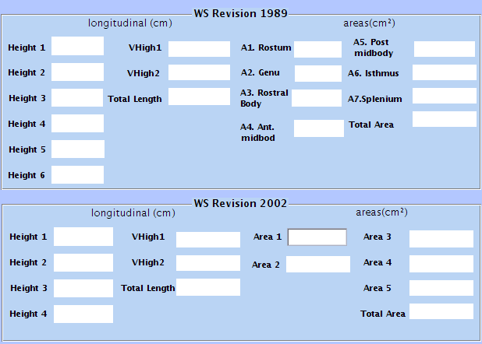

3.8. Click on 'Start delineation'. The delineation uses point-to-lines and you must go around the CC structure as precise as possible and with as many points needed.
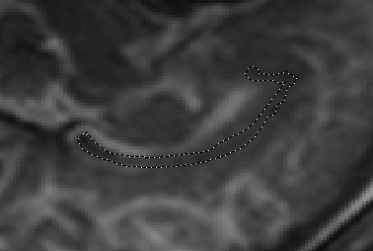

After being certain the delineation is fine, by clicking Enter, the delineation will appear in yellow.
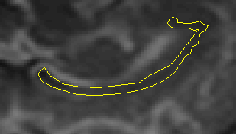

3.9. If it is fine, then 'Validate delineation'; if not, click on the orange 'Cancel' button and start again.
3.10. A new button will appear on the right which is 'Fix rectangle'. Click on it.
3.11. The program will give you the instruction of 'Put the blue circle at the position A of Wiltelson scheme', meaning that the blue circle orientates the anterior part of the CC. Click enter and start the rectangle inside the image.
3.12. The rectangle can be turned around and be put smaller by your will. IT IS VERY IMPORTANT THAT THE RECTANGLE BOX BE PARALLED TO THE ANTERIOR AND POSTERIOR PART OF THE CC.
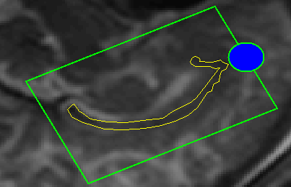

3.13. Click enter, then a blue box and a line will appear.
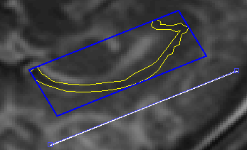
The blue box must be aligned to the axis of the CC to include both extremities. If not, you must restart.
The white line is a very important guide. It defines the G spot that it a key point in the Witelson scheme in the anterior part of the CC. If misplaced, it will alter the measurements. This white line can be clicked and dragged and it must be in the exact anteriormost point on the inner convexity of the anterior callosum, as follows:
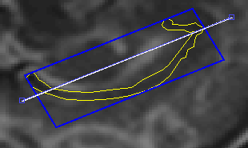

3.14. When fixed the while line, click Enter. The division will occur and appear:
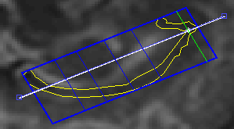

Plus, the button 'Calculate parameters' will appear. Click on it. The measurements will appear.
3.15. For posterior revision, save the image and save image+ROI inside the folder GUI_CC, naming the files with as: NHC and NHCroi (00001 and 00001roi)
3.16. To properly stored data and have a log with all results, you MUST fill the NHC field with the appropriate patient number, then click on 'Validate patient'.
3.17. Data extraction
Para instalar estos ficheros:

1. Descargar ficheros adjuntos

2. Abrir la carpeta GUI_CC que se encuentra en el escritorio de la sesión de connectomics

3. Mover los ficheros a esa carpeta y ya está.

4. Abre la carpeta mats que se encuentra dentro de GUI_CC y elimina los ficheros que tengan fecha de creación anterior al día de ayer 17/06 (extensión .mat'). Son los análisis realizados con la versión anterior.

En cuanto al programa para extraer los datos en Excel, comentarte que sólo funcionará con las imágenes que hayas analizado con la versión que instalamos ayer.

Para extraer los datos haz lo siguiente:

1. Aseguráte que en la carpeta GUI_CC/mats sólo hay ficheros con fecha de ayer. Si hay otros con fechas anteriores deberás eliminarlos.

2. Desde el mismo sitio desde donde abres el programa para la delineación, escribe en la pantalla

Extraermedidas

3. Se abrirá otro programa.

4 Si pulsas el primer botón, le indicas donde quieres que te guarde el fichero .csv (Excel) con los datos

5. En la barra de abajo te indicará el nombre que se le pondrá por defecto a ese fichero. Si quieres poner otro, sólo tienes que borrar lo que hay y escribir el nombre que quieras.

6. Pulsa sobre el botón Export Data. Se abrirá una pantalla para que selecciones la carpeta donde se encuentran los ficheros .mat en este caso es la carpeta mats que se encuentra dentro de GUI_CC. Cuando haya terminado mostrará un mensaje de aviso de que ha sido correcto. Si ves que no sale nada, mira el matlab a ver si ha salido un mensaje en rojo, entonces habrá fallado. En tal caso, si me puedes enviar por e-mail lo que esté en rojo para ver que puede estar pasando te lo agradeceré.

